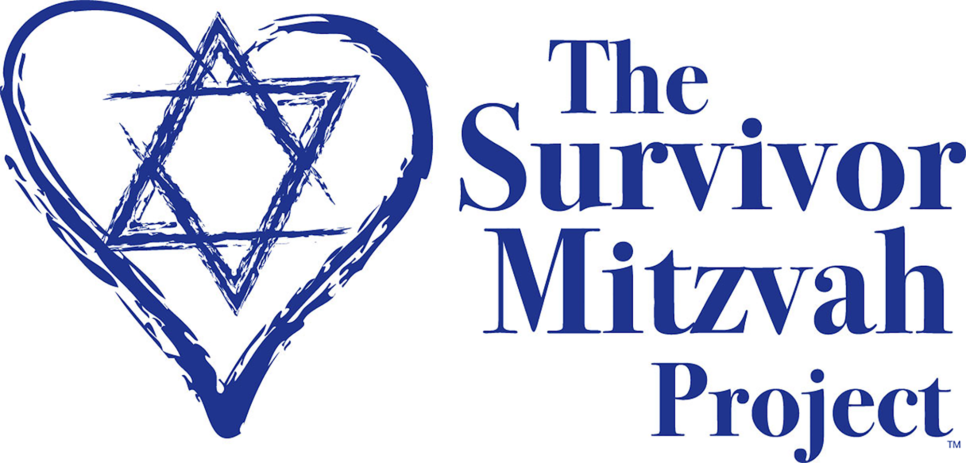

The Survivor Mitzvah Project receives thousands of letters from elderly Holocaust survivors all across Eastern Europe thanking us for our help. Her are just a few expressions of their thanks to everyone who has supported them.

Anna Israelevna, age 94/Ukraine: “I do not have enough words of gratitude in my vocabulary to thank you for everything you do for me. I don't know how to thank you for such support. You brought me back to life. Till the end of my days I will be in irredeemable debt to you. Thanks to your organization, The Survivor Mitzvah Project, I stay alive, I am warm, I have food, and because you helped me, I was able to have the operation on my eyes, and now I can see. Without your help, I would be blind. I am thankful to everyone in my American “family”. A low bow to you all for your kindness and humanity.”

Hirsch Alterovich, age 94/Lithuania: I received the money, for which I am very grateful. It allows us to buy food and medicine. Your letter is like a breath of fresh air for me. Other than you, no one writes to me. In my long life I have learned to understand that the most important things in this world are goodness and compassion. It’s such a pleasure when somebody remembers you. I am amazed that there are such wonderful people in the world. I hold on only to this.”

Eva Semonovna, age 86/ Belarus: While I was opening the envelope my hands shook with emotion. There are no words to express my gratitude toward you for your help and attention. Right now, when I write these lines there is a lump in my throat from tears…I am sitting and crying that total strangers are taking care of me.

Valeria Yevgenievna, age 84/Ukraine: “Today I received the money you sent. Because of you, I believe in miracles. It’s hard to express how much I appreciate your personal caring and compassion, as well as from those who support your organization. As long as there are people like you, mankind need not worry: kindness will save the world.”

Moisejus P., age 83/Lithuania "You saved my life. I sometimes think what would have become of us without you? I find only one answer...only because of you are we still living...

Tzylia Moishe-Penkhosvna Bederman, age 89/Ukraine: “My dearest friends... I can’t imagine how I would survive without your help... I couldn't even afford an apple.”

Genrich A., age 84 /Lithuania “I can’t find words to express our gratitude to you for such tremendous help. Your financial aid has supported us through this unimaginable time, which feels like it will never end. You can’t imagine how amazing it is for us that people who have never even seen us still think about us, sympathize with us, and support us during these terrible times. We will be grateful to you for everything till the end of our days. Our heartfelt thanks to all of you!”
Musya Moiseyevna Vainshteyn, age 83 /Ukraine – “Food has become much more expensive, as well as utility payments, especially for heat, twice as much as before. My dear friends, I am very grateful to you for your support. If not for your help it would be very hard for me to survive. You are doing wonderful things. You are helping people and the Almighty will repay you a thousand fold.” Ukraine

Viktor Karpenko, age 92/Ukraine: “Thank you from the bottom of my heart for not forgetting me during these difficult times. I believe that my health will improve. After receiving your aid, we bought all the necessities and medicines that were recommended, including those I could not afford before.

Fanya& Basya Kreyn/Belarus: We are sisters. We cried when we received the money and appreciation and the love. Thank G-d he gives to the world people like you who care about us. We kiss all of you who are helping us.

Reuven Zeligmanis, Lithuania: I want to thank you from the bottom of my heart. You so open-handedly make my own and other people’s lives better. It’s impossible to imagine the unbearable situation of old, unhappy people, forgotten by everybody. Yours are noble actions. Your generosity is worth all the diamonds in the world.

Mina Zalmanovna Sheffer, age 85/Belarus: “Thank you. You are my rescuers.”

And a devoted daughter, herself ill, overwhelmed with expenses and care required to provide her elderly mother (severely ill with multiple diseases: heart disease, diabetes and advanced Alzheimer’s) with the specialized medical and home care needed, shares the life changing support her mother received due to you the kindness of our donors:

Sveta Bederman/Ukraine: “You can’t even imagine how your support impacted my mother's life. Thanks to you, she now lives happily in a nice, warm, new apartment with all the conveniences. She can afford good food and the medical help that is so expensive here. She feels really good, never complains about anything. My dearest friends, I want to say again that you are creating miracles! In our difficult times you find the means to help elderly people like my mother who suffered so much, and brighten their later years. I bow before you!”

For many survivors, the help they receive from American donors is the first kindness these brave individuals have ever known.

www.survivormitzvah.org
You can make a difference!

